Hollydale Technology Needs Assessment Narrative

Without question, technology is a vital component of a twenty-first century learning experience. At Hollydale Elementary, there is a vast array of technology related resources to support student learning. Each classroom is equipped with multiple desktop computers, student laptop computers, interactive white boards, and remote assessment devices. While each of these resources is easily accessible, the actual usage of these resources proves to be somewhat limited. The following report will outline the results of the Hollydale Technology Needs Assessment, related implications, and conclusions drawn from resulting data.
This needs assessment was distributed for administration the week of October 1, 2012. The survey was distributed to certified staff members within the school with participation being completely voluntary. At the time of analysis, seventeen certified teachers had completed the survey. The breakdown of survey completion was moderately balanced between kindergarten, first grade, second grade, third grade, and support teachers. It is important to note that survey was not completed by any teachers in fourth or fifth grades. In addition, due to the low number of participants and administrative conditions, the validity of the results remains limited. Approximately 70% of survey participants had between four and ten years of teaching experience. This data was collected to establish a possible link between teaching experience and perceived technology competency, which would influence the level and type of professional development offered. Approximately 47% of participating teachers evaluated their instructional technology skill level to be in the “basic” range while approximately 47% cited their level as being “proficient.” Only one participant indicated their instructional technology skill level to be “advanced.” When self-evaluating technology usage in the classroom, approximately 67% of teachers selected “used by the teacher for direct instruction” as their primary integration of technology. The survey results also concluded that mathematics and writing are the primary content areas in which technology is most frequently integrated. Participants also indicated that math is the content area in which more technology integration is most desired (31.3%). When assessing professional development in relation to technology integration, participants indicated a strong agreement with the need for varied professional development opportunities. 75% of participants indicated that they would benefit from professional development related to using technology to enhance assessment, facilitate differentiation, and facilitate student-centered learning experiences. Furthermore, participants indicated a strong desire to learn more about various technology resources within the classroom. Approximately 77% of participants indicated a desire to learn more about ActivInspire (Promethean) and 35% indicated a desire to learn more about using iRespond for assessment purposes. In addition, Kidspiration/Inspiration, Fraction Nation, TimeLiner, PhotoStory, and Movie Maker were also areas in which participants indicated a desire for further learning. The majority of participants indicated that “Informal training by colleagues” was the preferred professional development model (43.8%) with “Individual or small group coaching” or “In-Service or workshop” being the next preferred models. Finally, to assess the perceived access to technology based resources, participants were asked to identify resources that were available for instructional purposes. Participants indicated high levels of access (>75%) to desktop computers, laptop computers, interactive white boards, LCD projectors, and document cameras.
After analysis of the data, many conclusions can be drawn about the integration of technology in instruction at Hollydale Elementary. The data suggests that access to instructional technology resources is a definite strength. Teachers consistently indicated high levels of accessibility to resources ranging from interactive white boards to iRespond remote devices. Accessibility is the foundation of technology integration in the classroom and, at Hollydale teachers perceive high levels of accessibility. Another strength, as established by the data, is evidence that the majority of staff members have a desire to learn more about technology related resources, skills and strategies. This is evidenced by between 68.8% and 75% of participants indicating that they would benefit from trainings in specifically identified areas. In addition, 76.5% of participants indicated a desire to learn more about the ActivInspire software (to be utilized with the Promethean Boards). This desire, coupled with the perceived high levels of resource accessibility leads to the conclusion that teachers at Hollydale understand the benefit of this resource and desire to more fully utilize it in instruction.
While the data clearly establishes the strengths of educational technology usage, it also indicates some areas of concern. As shown through the statistics, the vast majority of technology usage in the classroom involves teacher directed processes. No teachers reported students as being the primary users of technology in the classroom. Approximately 27% of participants indicated that the primary use of technology in their classroom relates to administrative tasks (for example, submitting attendance). Aside from that percentage, 66.7% of participants reported that the primary use of technology was related to direct instruction by the teacher. In this case, the technology is being used, but the potential is significantly limited by the mode of integration. While this does indicate that teachers are using technology, it is vital to understand that, “Effective tech integration must happen across the curriculum in ways that research shows deepen and enhance the learning process. In particular, it must support four key components of learning: active engagement, participation in groups, frequent interaction and feedback, and connection to real-world experts” ("Why integrate technology," 2008). It appears that the number of participants using technology for these purposes is significantly limited. This data further corroborates the perceived teacher skill level regarding educational technology, as nearly half of participants indicated a “basic” level of skill. These areas of concern provide specific areas of “need” that can be targeted by focused professional learning opportunities at the school level.
Generally speaking, data indicating a strong “desire to learn” is a very powerful element. While numerous external influences can impact the other identified strengths related to technology needs at Hollydale, the intrinsic desire of teachers to more fully utilize these resources is significant. This desire to learn paired with the areas of concern noted above clearly outline valuable information for the planning of professional learning opportunities. In moving forward, it is clear that teachers need to learn strategies and techniques to facilitate student use of technology. More simply stated, the teachers need to learn how to put the technology into the hands of the students in a way that enhances the learning experience. This process is one that will first require teachers to more deeply understand the available resources and their capabilities. It will also require teachers to move beyond a perceived “basic” educational technology skill level. With a systematic plan based upon the established needs, the integration of technology at Hollydale Elementary can be significantly enhanced.

Hollydale Technology Needs Assessment

This survey was created, distributed, and administered using www.surveymonkey.com. This needs assessment can be found at http://www.surveymonkey.com/s/RWYL53D.

Background Information:

- What grade level do you teach? (Drop Down Menu Options)

- How long have you been teaching?
  - 0-3 Years
  - 4-6 Years
  - 7-10 Years
  - 10+ Years

- How would you rank your skill level in using technology in the classroom?
  - Basic
  - Proficient
  - Advanced

- In your classroom, describe how technology is most often used.
  - By the teacher for administrative tasks
  - By the teacher for direct instruction
  - Equal usage by the teacher and students
  - Primarily used by the students
  - Other (Please Specify)

- In which content area do you use technology most frequently?
  - Reader’s Workshop
  - Writer’s Workshop
  - Language Arts
  - Mathematics
  - Science
  - Social Studies
  - Health
  - Other (Please Specify)

- In which content area would you like to incorporate technology more often?
  - Reader’s Workshop
  - Writer’s Workshop
  - Language Arts
  - Mathematics
  - Science
  - Social Studies
  - Health
  - Other (Please Specify)
- I would benefit from professional development on…
Agree Possibly Disagree
Locating online resources to support student learning
Using technology for student-centered learning experiences
Using technology to enhance assessment
Using technology for differentiation
Aligning content standards and technology standards

- Which resource(s) would you like to learn more about? (allow multiple selection)
  - ActivInspire
  - iRespond
  - Fraction Nation
  - Kidspiration/Inspiration
  - TimeLiner
  - PhotoStory
  - MovieMaker
  - Other (please specify)

- What type of technology based professional learning would you most value?
  - Individual or small group coaching
  - Informal training from colleagues
  - In-service or workshop
  - Online Professional Development

- Which of the following technology related resources do you have access to at Hollydale? (allow multiple selection)
  - Desktop Computer
  - Laptop Computer
  - Netbook Computer
  - Interactive White Board
  - Smart Table
  - LCD Projector
  - Document Camera (Elmo)
  - iRespond System
  - ActiVote System
  - Ipad(s)
  - iPod(s)
  - Other (Please Specify)

Hollydale Technology Needs Assessment Results
Results by Question
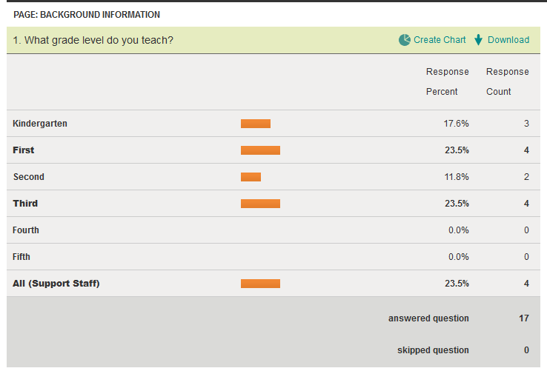
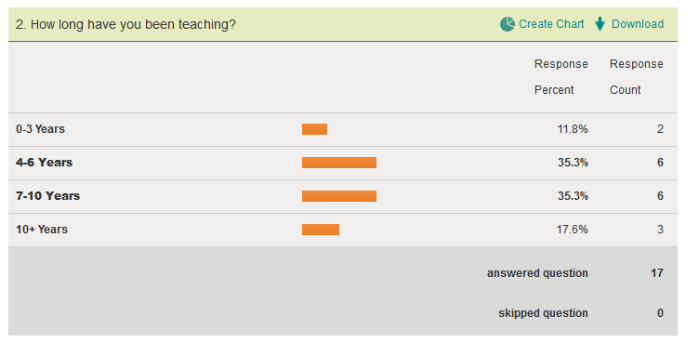
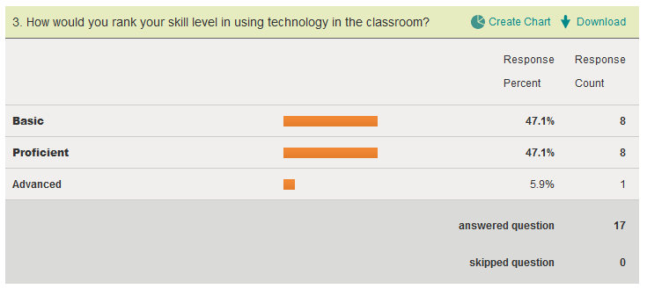
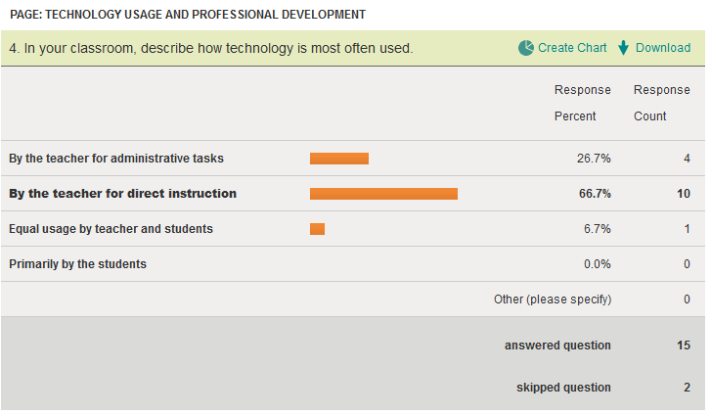

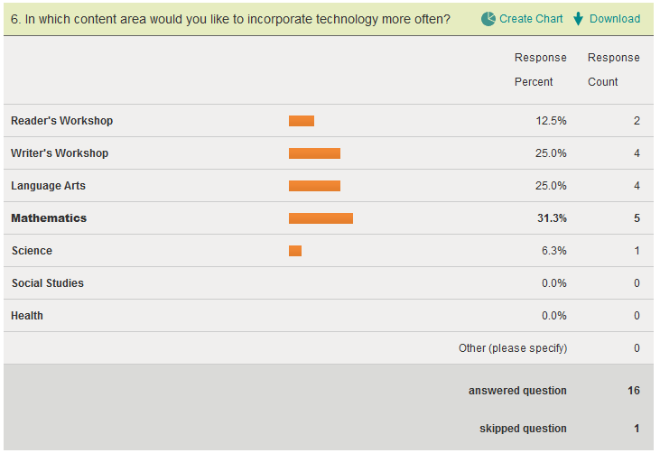
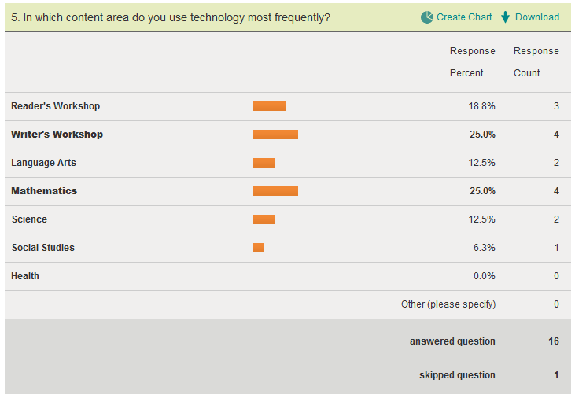
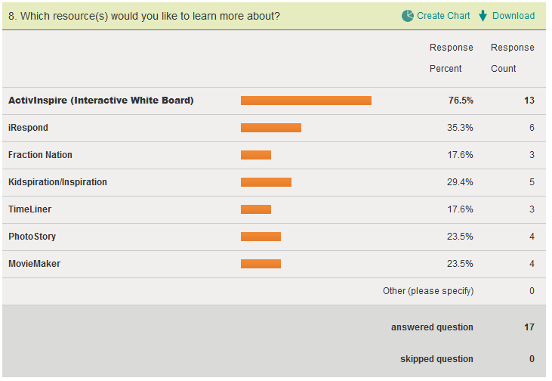
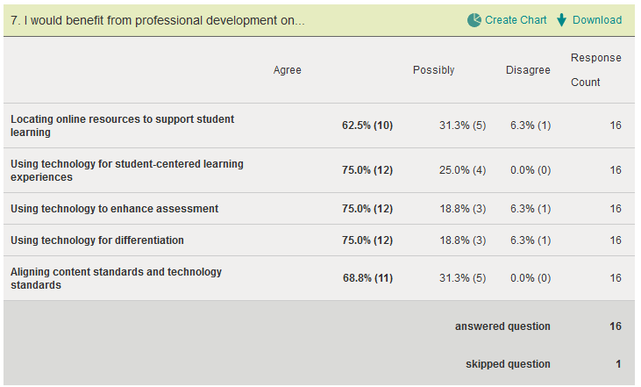

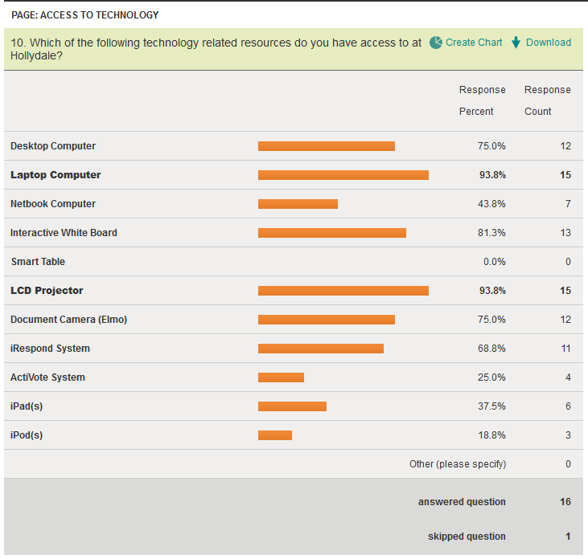
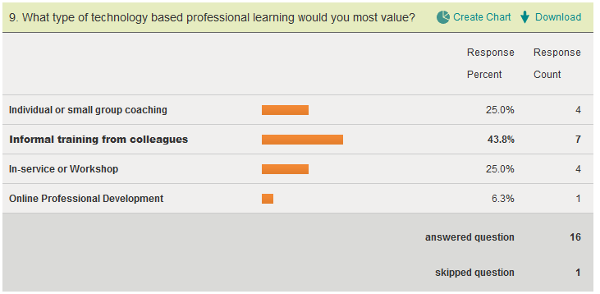
Citations

M. Phillips. Hollydale technology needs assessment. (2012, October 1).
http://www.surveymonkey.com/s/RWYL53D

Why integrate technology into the curriculum? The reasons are many. (2008, March 16).
Edutopia , Retrieved from http://www.edutopia.org/technology-integration-introduction

