Miss Phillips’ Class
Online Learning Communication Guide

Introduction:

Welcome terrific third graders! This guide will help you as you learn how to communicate in our online class. Read through this with your educational coach and talk about the ways you will be sharing information with others online.

What is communication?

Communication is the way we share ideas or information with others. When you communicate, you are passing thoughts, opinions, or information to someone else. Sometimes, people communicate by talking, writing, or even drawing while other times people communicate by shaking their head or giving a thumbs-up sign. In this guide, we are going to be learning about communicating online.

How will we communicate?

In our online class, we will communicate in a lot of different ways. You may have used some of these communication tools before while some might be new to you. We will be using e-mail, blogs, and discussion boards to share and gather information and ideas. You will find a section about each of these communication tools in this communication guide.

How do I ask a question or get help?

There are many different ways to ask questions or get help in our online class. If you have an important question for the teacher, you can send an e-mail through Georgia View Vista. In the event of an emergency, you may also send an e-mail directly to the teacher at MissPhillips@Onlineclass.com. If you have a question about an assignment or project that another student could answer, you can post on a discussion board. One of the coolest things about online classes is that you can get help from the teacher and get help from other students. In the next section of this guide, you will learn about these different ways you can communicate in our class.

Types of Online Communication:

Announcements:

Just like in a regular school, sometimes we will need announcements made in our class. If there is an important announcement to share with the class, I will send it through Georgia View Vista. This means that it will pop up on your screen while you are working. Don’t worry when you see it, just read it and make sure you understand the information. You can always go back to the announcement section of by clicking on the “Announcements” label.

E-Mail:

In our online class, e-mail is a great way to share ideas with others. It’s like sending a letter to someone through the internet…without stamps or envelopes! You each have your own unique e-mail address that you can use to send and receive messages. Make sure that you do not share this e-mail address with others outside of the class, but feel free to use it to communicate with your classmates about assignments, projects, and class questions.

The subject line is where you write what the message is going to be about… it’s kind of like a preview. When writing on the subject line, start with your last name then write 2-3 words about the e-mail topic. For example, “Phillips- Module 3 Question.” When you write an e-mail, remember to be specific and clear so that the reader understands what you are saying or asking. After you type your message, make sure you proofread it carefully to catch any mistakes. Then, press “SEND” to send your message. Once you send a message, you cannot get it back, so make sure you send carefully!

Closer Look:
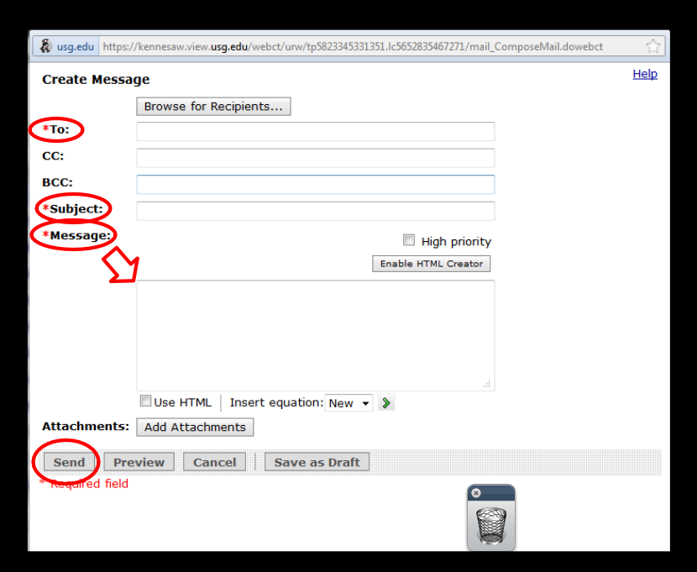
To: Who are you e-mailing? Enter the e-mail address(es) of the people you are sending it to.
Subject: What is the e-mail about?
On the subject line, write your last name and 2-3 words about the topic of your e-mail.
Message: Write the message in the box. Remember to proofread it before you send it to make sure it’s correct.

E-mailing the Teacher:

You can e-mail the teacher anytime by typing MissPhillips@onlineclass.com in the “TO” box. Responses to e-mails will usually come within 24 hours. That means, if you send a message at 10:00am on Monday, you will probably have a response by Tuesday at 10:00am. Remember, you can e-mail the teacher at any time. But, remember to be patient, just because you send the message does not mean that it will be seen immediately.

Blogs:
A blog is like a personal journal on the internet. It is a place where you can write about your ideas or share information you have learned in class. When you write a blog post, it should be at least 5 sentences and should answer the question or address the topic stated in the directions. Once you publish a blog, or send it on to the internet, anyone in the class will be able to see it. Make sure your blog post is fantastic and free of mistakes before you post.

One of the coolest parts about blogging is that you can read and respond to the blog posts of your friends. In fact, each blog has a section where you can write a message to the blog author. This is where you can share your thoughts about their posting or the information shared and you can ask questions about their blog post. When you respond to a blog post, you should include these three parts:
- Praise: A compliment about the original post
- Share: Share your ideas, thoughts, or knowledge about their topic/question
- Clarify: Ask a question about the topic or ask for clarity if you do not understand something
All blog responses should be posted by 5:00pm on Tuesday.

Each blog you write in our class will be graded using a rubric that you will find in the module. You will also be graded on your blog comments to other students in the class. Remember, we when writing blog posts and comments it is important to be respectful of other students, even if you do not agree with their ideas.
Blog Rubric:

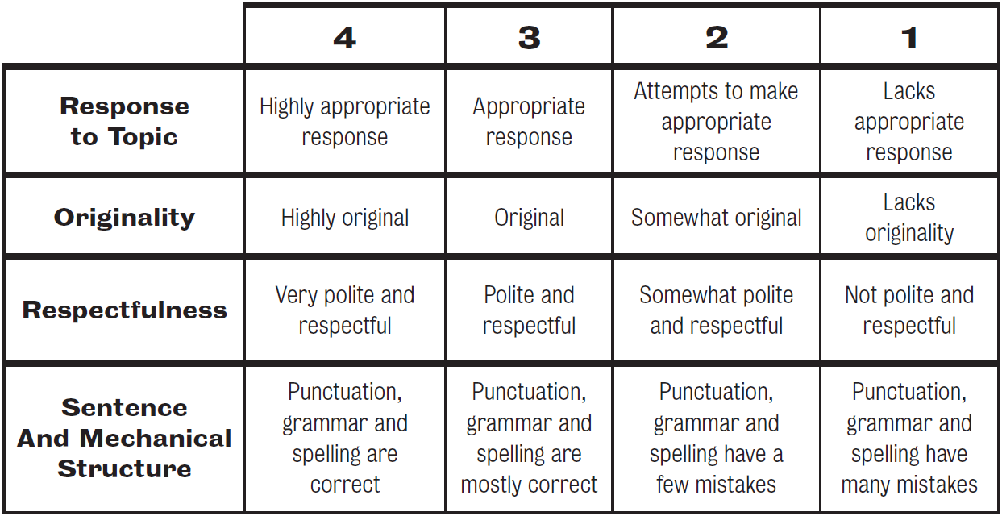
(From www.scholastic.com)

Discussion Boards:

The discussion board is a place that you can have conversations with different groups of students. Instead of using your voice to talk to others, on the discussion board, you will type what you want to say. Then, other people can respond. Each topic for discussion will have its own “board” so the conversations can stay focused and orderly. When communicating on the discussion board, remember to respond to the topic listed. Just like with blogging and blog commenting, you will be graded on the post and your responses to the post. And, just like in any conversation, be polite and respectful of the ideas presented by other people.

You’ll notice in Georgia View that we have a discussion board called TEAM PHILLIPS ISLAND. This is a discussion board where you can talk to and get to know the other students in the class a little better. You do not have to talk about school stuff, but remember that anyone (including the teacher) can see what you post, so make sure it is kind, respectful, and appropriate.

Netiquette:
The word “Netiquette” is the combination of two other words: internet and etiquette. Netiquette is a set of expectations for how you communicate online. Just like you use good manners when talking to others, it is important to use good manners when you interact with others on the internet. Let’s take a look at some important things to remember.
- Respect! In all your online interactions, be respectful of others and treat others kindly.
- Be patient If you are waiting on a response or are waiting for someone to write something, be patient. Just because you send something does not mean the other person receives it instantly.
- Respond appropriately- if someone asks you a question online, be sure to respond in an appropriate amount of time. When having an online discussion, it is also important to appropriately comment.
- Never type in ALL CAPITAL LETTERS. Capitalizing all the letters is like yelling on the internet.
- If you want to share your feelings, feel free to add an emoticon. Sometimes, this helps others better understand your thoughts. :) :(
- Don’t use abbreviations for phrases. Writing LOL, OMG, SMH, and other abbreviations is quick and easy, it is not appropriate for our online learning.
- Write things carefully and proofread before you post something to make sure that it is easily understood and clear to the reader.
- If there is a subject line on a communication tool, always include a 2-3 word subject that explains the topic of the message.

Note: This communication guide is specifically designed for third grade students in Miss Phillips’ Online Class.
References:

Berge, Z. (2002, April 02). The role of the online instructor/facilitator. Retrieved from
http://www.emoderators.com/moderators/teach_online.html

Edelstein, S., & Edwards, J. (n.d.). If you build it they will come: Building learning communities
through threaded discussions. Retrieved from http://www.westga.edu/~distance/ojdla/spring51/edelstein51.html

The core rules of netiquette. (n.d.). Retrieved from
http://www.albion.com/netiquette/corerules.html

Image:

(2011). Global communication online. (2011). [Print Photo]. Retrieved from
http://vd.pcn.net/en/index.php?option=com_content&view=article&id=355:global-communication-online&catid=32:news-2011&Itemid=35

